Transcription is the process by which the information in a strand of DNA is copied into a new molecule of messenger RNA (mRNA). DNA safely and stably stores genetic material in the nuclei of cells as a reference, or template.

Transcription is carried out by an enzyme called RNA polymerase and several accessory proteins called transcription factors. Transcription factors can bind to specific DNA sequences called enhancer and promoter sequences in order to recruit RNA polymerase to an appropriate transcription site. Together, the transcription factors and RNA polymerase form a complex called the transcription initiation complex. This complex initiates transcription, and the RNA polymerase begins mRNA synthesis by matching complementary bases to the original DNA strand. The mRNA molecule is elongated and, once the strand is completely synthesized, transcription is terminated. The newly formed mRNA copies of the gene then serve as blueprints for protein synthesis during the process of translation.

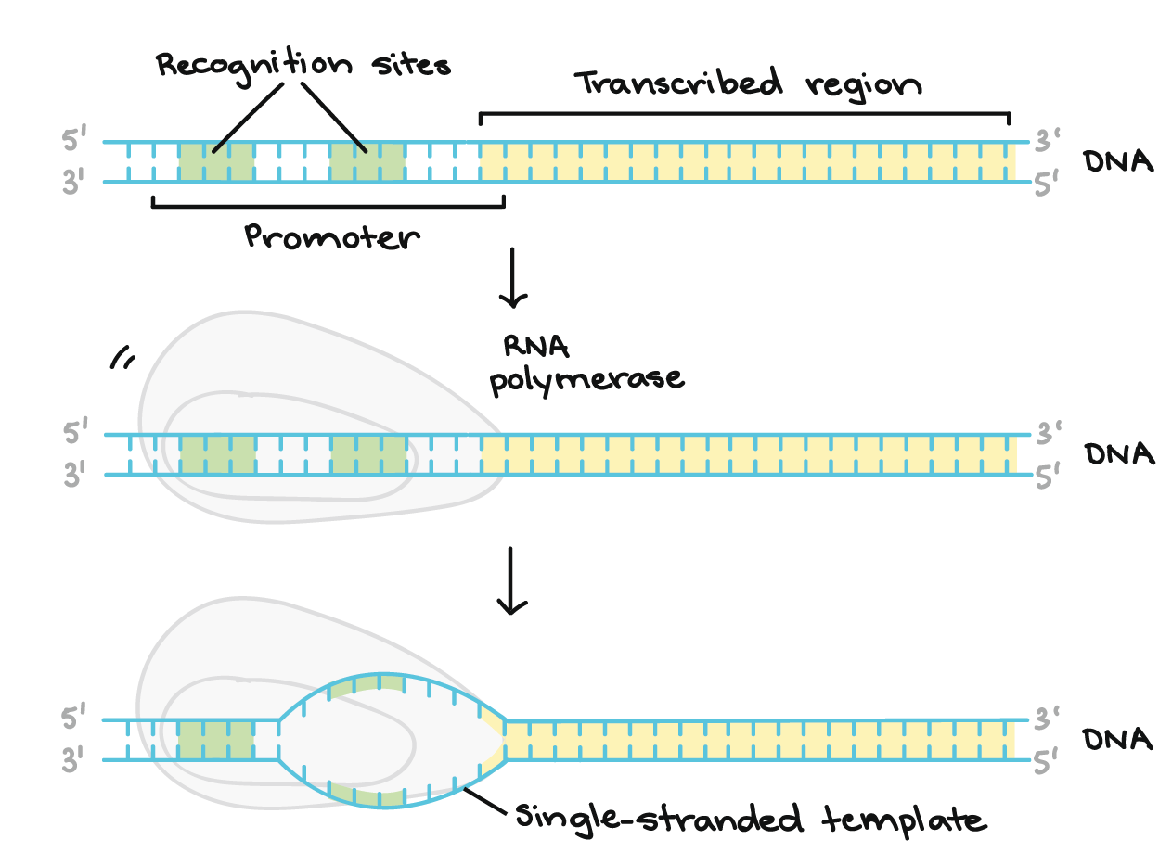

RNA polymerase synthesizes an RNA transcript complementary to the DNA template strand in the 5' to 3' direction. It moves forward along the template strand in the 3' to 5' direction, opening the DNA double helix as it goes. The synthesized RNA only remains bound to the template strand for a short while, then exits the polymerase as a dangling string, allowing the DNA to close back up and form a double helix.

In this example, the sequences of the coding strand, template strand, and RNA transcript are:

Coding strand: 5' - ATGATCTCGTAA-3'

Template strand: 3'-TACTAGAGCATT-5'

RNA: 5'-AUGAUC...-3' (the dots indicate where nucleotides are still being added to the RNA strand at its 3' end)

